Carbon Coop - Committee Member Nomination Pack
AGM meeting, 17th July 2020

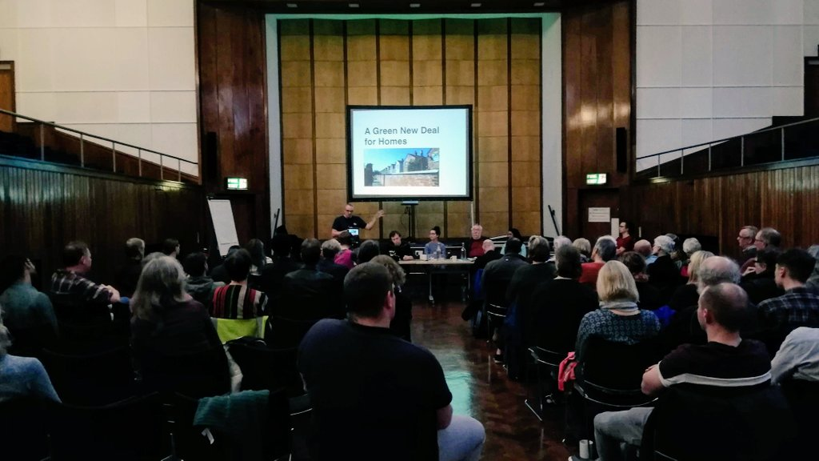

- Introduction
- Roles and Responsibilities
- Nomination form

1. Introduction
Carbon Coop is a community benefit society, it exists to assist its householder members in reducing their household carbon emission and has a broader remit to reduce carbon emissions from the wider community.

Carbon Coop is governed by a group of honorary Committee members elected by the wider membership at the society's Annual General Meeting. The co-operative is an exciting, innovative and ambitious organisation with a small staff team, but it relies on the time, enthusiasm and commitment of these volunteer committee members and we encourage members to consider standing for election.

This pack outlines the role and responsibilities of a Committee member, specifies what is involved and includes a nomination form to submit your application.

Legal form
Established in 2011, Carbon Coop is a Community Benefit Society - a distinct legal cooperative form registered with the FCA. A community benefit society is a not-for-profit form accountable to its members and the wider community. We subscribe to the seven cooperative principles and are members of Cooperatives UK, however, the FCA refuse to register the word 'cooperatives' in the name of societies (something Cooperatives UK and its members challenge), so our official name is the Society for the Reduction of Carbon Limited, and we trade as Carbon Coop.

Committee Members
Under our rules, the committee is the ruling executive of Carbon Coop and must have a minimum of seven members and a maximum of 15. Committee members are elected at the coop's annual general meeting by the members present. To stand for election you need to be a current, paid up member of the cooperative. The Committee also has the ability to co-opt new members at any given time should the need arise.

Time Commitment
The Committee currently meets every two months at meetings held in Manchester city centre (or latterly virtually!) that last around two hours. Committee members are expected to attend all meetings, a prolonged absence without good reason will lead to committee members being asked to step down. After each AGM, the new board reconsider the meeting time, frequency and location to ensure all members are able to attend.

Committee members may from time to time be asked to join sub-committees to consider certain topics or issues, and may be asked to make occasional, urgent decisions by email.

The day to day running of the organisation is delegated to staff members, accountable to the committee. We use the ‘Policy Governance’ or ‘Carver Governance’ model (https://www.policygovernanceassociation.org/resources/principles-of-policy-governance.html) which involves board members reviewing monitoring reports on progress against the organisation’s ‘Ends’ in advance of meetings.

Carbon Co-op has a formal induction process for new committee members as well as a Code of Conduct for the committee.

2. Roles and Responsibilities

The Role of the Committee
The Committee' role is broadly:
- To set the values, ethics and culture of the organisation
- To set the strategy and direction
- To provide accountable leadership
- To oversee business performance
- To determine and direct the organisation's risk profile
- To oversee the management team
- To ensure compliance with rules and statutory requirements
- To set policies and procedures and oversee their implementation
- To be accountable to members
- To vet new board members

The Committee is not there to:
- To become involved in day to day management
- To represent other roles ie personal business, job role, interest group etc. People are there to represent interests of the coop alone

The Role of a Committee member
There is no formal job description for a Committee member, but we think it includes:
- Providing your attention and commitment
- Challenging other board members and staff
- Being able to represent the membership – as a whole
- Having a basic standard of financial literacy
- Having good people skills – being part of a team
- Being able to listen, reflect and when required make difficult decisions
- Valuing different types and levels of commitment
- Being honest and open
- Showing accountability and transparency
- Accepting majority board decisions – even when disagree
- Bringing life experience and skills from outside
- Being patient and persistent

The Committee welcomes people with all kinds of skills, experiences and backgrounds.

Board member responsibilities
Carbon Coop are committed to providing formal committee member training on members' legal responsibilities. In short, the legal responsibilities of a society board member are laid down in Society law and are analogous to a Company Director - in fact via Common Law and Case Law, Company Director Law also applies to Committee members.

Society law on directors
- Obey the law
- Duty of good faith - fiduciary duty
- Duty to take care

Companies codified duties – in Company Law
- Duty to act within powers
- To promote the success of company – fiduciary responsibility
- Duty to exercise independent judgment
- Duty to exhibit reasonable skill, care and intelligence
- Duty to avoid conflicts of interest
- Do not accept benefits from third parties
- Duty to declare interest in proposed transactions with company

Additional regulation and legislation
- Insolvency act
- Health & Safety at Work
- Corporate Manslaughter and Homicide
- Employment Law

The co-operative offers formal training to new members on the role and responsibilities of society committee members.

3. Nomination form

Please complete this form, in print or electronically, and return to the Society Secretary: info@carbon.coop

i) Name:
ii) Address:

iii) Are you a member of Carbon Coop? YES/NO

iv) Are there any legal reasons that might prevent you from fulfilling this role?*

v) Are you able to make a reasonable time commitment to the committee eg 6 meetings a year, a strategy day and occasional email contributions? YES/NO

vi) Briefly outline a personal statement/biography (200-300 words)

* Such reasons include: discharged bankrupt, disqualified or barred as a director in the past etc

